Research Report on:-

Web Application Tools for Vulnerability Assessment and Penetration Testing (VAPT)

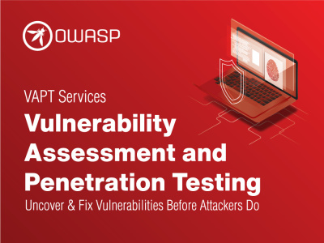

Introduction
Vulnerability Assessment and Penetration Testing (VAPT) is a crucial process for identifying and mitigating security weaknesses in web applications. This report explores various tools used in VAPT, their functionalities, and provides examples of how they are used to ensure the security of web applications.

Web Application (VAPT) Fundamentals
Web Application: A web application is a software application that runs on a web server and can be accessed through a web browser. Unlike traditional desktop applications that are installed on a local machine, web applications are hosted on a remote server and require internet access to function. They typically rely on web technologies such as HTML, CSS, JavaScript, and server-side programming languages like PHP, Python, Ruby, or Java.
Components of a Web Application:

* Web Browser (Client-Side): The interface through which the user interacts with the web application. It displays the application content and communicates with the web server via HTTP or HTTPS.

* Web Server: The server that handles HTTP requests from the client, processes them, and sends back the appropriate response. Popular web servers include Apache, Nginx, and Microsoft IIS.

*Application Server: The server responsible for executing server-side scripts, processing user inputs, and managing business logic. It communicates with the web server to deliver dynamic content.

* Database Server: The server that stores and manages data required by the web application. It can be relational (e.g., MySQL, PostgreSQL) or non-relational (e.g., MongoDB, Cassandra).

* Backend Logic: The code and algorithms running on the server side that handle data processing, calculations, authentication, and communication with the database.

* Frontend: The part of the application visible to users, consisting of HTML, CSS, and JavaScript, which is rendered by the web browser. This includes the user interface (UI) and any client-side logic.

* API (Application Programming Interface): APIs are used to facilitate communication between different components of a web application or with third-party services. REST and GraphQL are common API architectures.

How Web Applications Work:

* Client Request: The user makes a request to the web server by entering a URL in the browser or clicking on a link/button.

* Request Handling: The web server receives the request and forwards it to the application server for processing. This may involve executing server-side scripts, querying the database, and applying business logic.

* Processing: The application server processes the request, often interacting with the database server to retrieve or store data. This might involve checking user credentials, calculating results, or generating a dynamic response.

* Response: The processed data is sent back to the web server, which then forwards it to the client’s browser.

* Rendering: The browser renders the response (usually in HTML, CSS, and JavaScript), and the user can view the requested page or data.

* Client-Side Interaction: The client-side code (JavaScript) may handle further interactions without needing to request new pages from the server, using AJAX or other techniques to update parts of the page dynamically.

Types of Web Applications:

*Static Web Applications: Display fixed content, and no interaction or user input is processed by the server (e.g., informational websites, portfolio sites).

* Dynamic Web Applications: Provide interactive and dynamic content. The server processes user inputs and may query a database to render content that changes dynamically (e.g., e-commerce sites, social networks).

* Single-Page Applications (SPA): A type of dynamic web app where the user navigates through a single HTML page, and content updates dynamically via JavaScript without refreshing the entire page (e.g., Gmail, Google Maps).

* Multi-Page Applications (MPA): A traditional approach where every change or user action results in a new page being loaded from the server (e.g., Amazon, Wikipedia).

* Progressive Web Applications (PWA): Combine the best features of web and native apps. PWAs work offline, are responsive, and provide a native app-like experience (e.g., Twitter Lite).

* Microservices-Based Applications: Built using a microservices architecture where the application is divided into small, independent services that communicate through APIs (e.g., Netflix).

Protocols Used by Web Applications:

* HTTP (Hypertext Transfer Protocol): The standard protocol used to send and receive data between a web server and a client (browser). HTTP is stateless, meaning each request is independent of the previous ones.

* HTTPS (HTTP Secure): An extension of HTTP that uses SSL/TLS to encrypt the data transmitted between the client and server, ensuring data integrity and security.

* WebSockets: A protocol providing full-duplex communication channels over a single TCP connection, allowing for real-time, bidirectional communication between a client and a server (e.g., for chat applications, online games).

* REST (Representational State Transfer): An architectural style for designing networked applications, relying on stateless communication and standard HTTP methods. RESTful APIs are commonly used in web applications.

* SOAP (Simple Object Access Protocol): A protocol for exchanging structured information in the implementation of web services, using XML as the message format. It is more rigid and secure compared to REST.

HTTP Request Methods:

* GET: Requests data from a specified resource. It's used to retrieve information without modifying the resource.

* POST: Submits data to be processed to a specified resource. Commonly used for form submissions, uploading files, and creating new records.

PUT: Updates or replaces all the current representations of the target resource with the request payload.

* DELETE: Deletes the specified resource.

* HEAD: Similar to GET, but it only retrieves the headers of the resource, not the body. Useful for checking if a resource is available.

* OPTIONS: Used to describe the communication options for the target resource.

* PATCH: Partially updates a resource with the data provided in the request payload.

1. Tools for Vulnerability Assessment
1.1. OWASP ZAP (Zed Attack Proxy)
- Description: OWASP ZAP is an open-source tool designed for finding security vulnerabilities in web applications. It is user-friendly and suitable for both developers and security professionals.
- Features: Automated scanners, passive scanning, scripting capabilities.
- Example Usage: Running an automated scan on a website to detect vulnerabilities like SQL injection, cross-site scripting (XSS), etc.
- Reference: OWASP ZAP Official Site
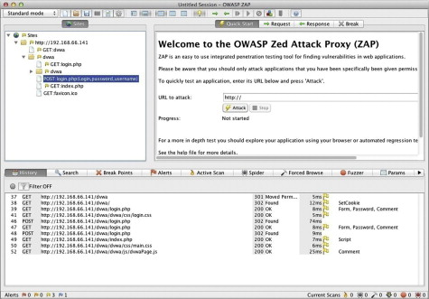
1.2. Nessus
- Description: Nessus is a widely-used vulnerability scanner that identifies vulnerabilities, configuration issues, and malware.
- Features: Comprehensive vulnerability database, customizable reports, extensive plugin support.
- Example Usage: Scanning web application servers to identify vulnerabilities such as outdated software versions or insecure configurations.
- Reference: Nessus Official Site
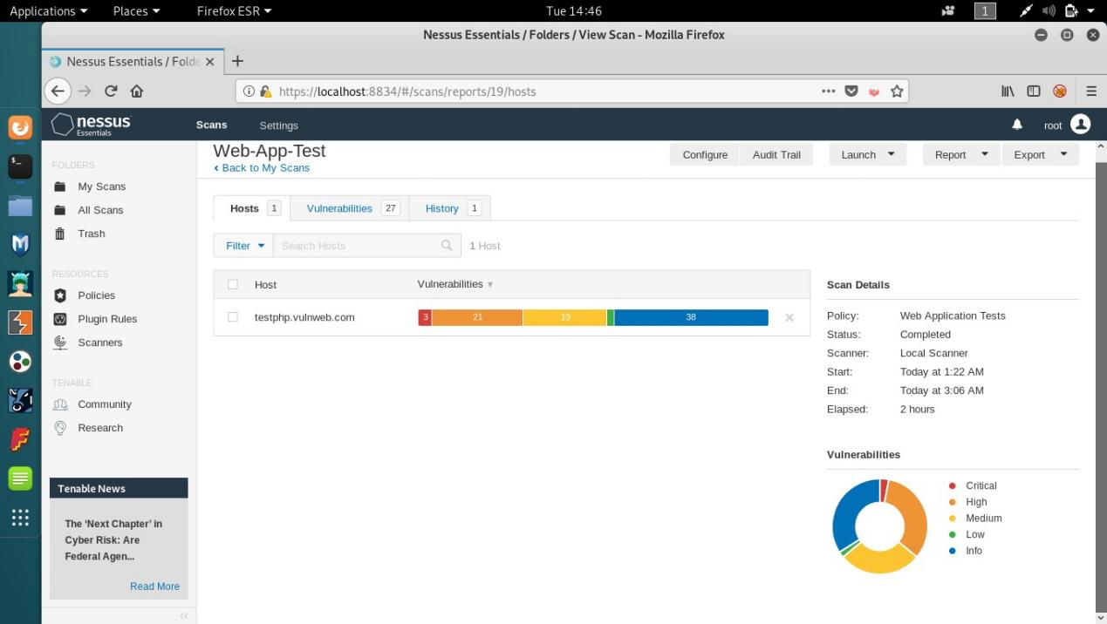
1.3. Qualys Web Application Scanner
- Description: Qualys Web Application Scanner offers a cloud-based solution to detect vulnerabilities and misconfigurations.
- Features: Automated scanning, vulnerability detection, compliance reporting.
- Example Usage: Conducting regular scans on a web application to ensure compliance with security standards and to identify potential threats.
- Reference: Qualys Web Application Scanner.
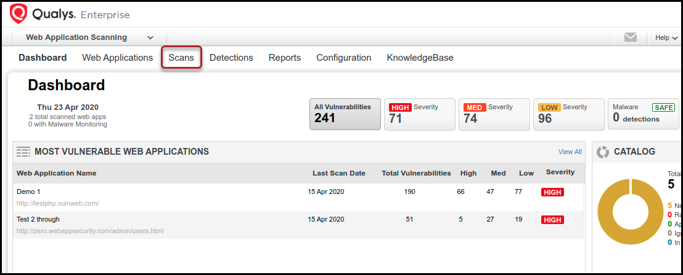

2. Tools for Penetration Testing
2.1. Burp Suite
- Description: Burp Suite is a popular penetration testing tool for web applications that provides comprehensive testing features.
- Features: Intercepting proxy, scanner, intruder, repeater.
- Example Usage: Using the intruder tool to perform brute-force attacks on login forms to test password security.
- Reference: Burp Suite Official Site

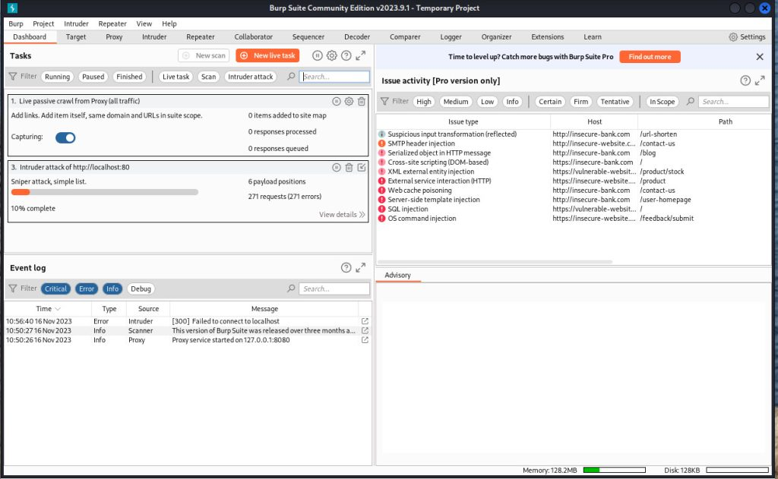
2.2. Metasploit
- Description: Metasploit is an advanced framework for developing and executing exploit code against a remote target machine.
- Features: Exploit development, payload creation, vulnerability scanning.
- Example Usage: Using pre-built exploits to test the resilience of a web application's security.
- Reference: Metasploit Official Site
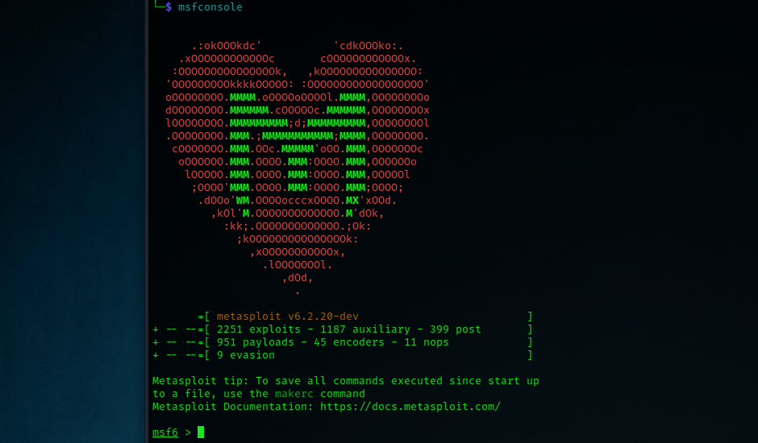
2.3. Nikto
- Description: Nikto is an open-source web server scanner that identifies various vulnerabilities.
- Features: Checks for outdated software, dangerous files, and security issues.
- Example Usage: Scanning a web server to identify potentially dangerous files or outdated software.
- Reference: Nikto Official Site
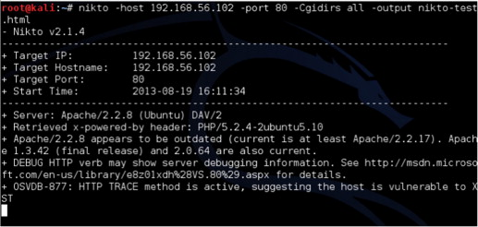

3. Combined Tools
3.1. Acunetix
- Description: Acunetix is a fully automated web application security scanner that detects a wide range of vulnerabilities.
- Features: Automated scanning, detailed reporting, vulnerability management.
- Example Usage: Running a comprehensive scan to find vulnerabilities across various web applications and generating detailed reports.
- Reference: Acunetix Official Site
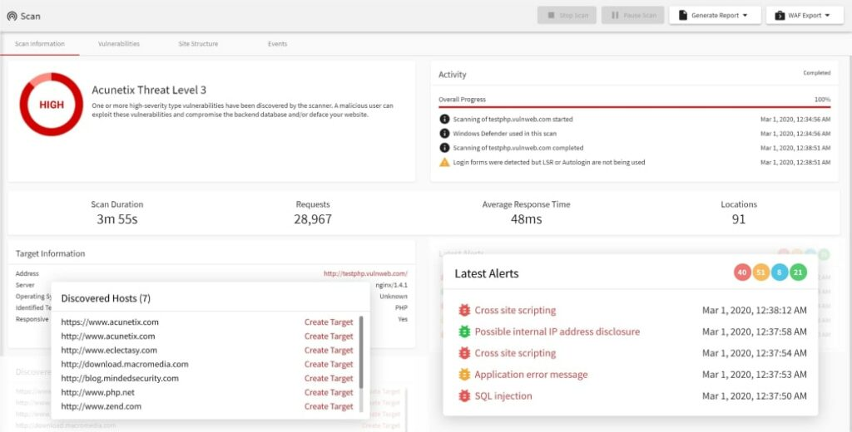

3.2. AppScan
- Description: IBM AppScan provides a suite of tools for web application security testing.
- Features: Static analysis, dynamic analysis, compliance reporting.
- Example Usage: Using dynamic analysis to test how an application behaves under various attack scenarios.
- Reference: IBM AppScan Official Site
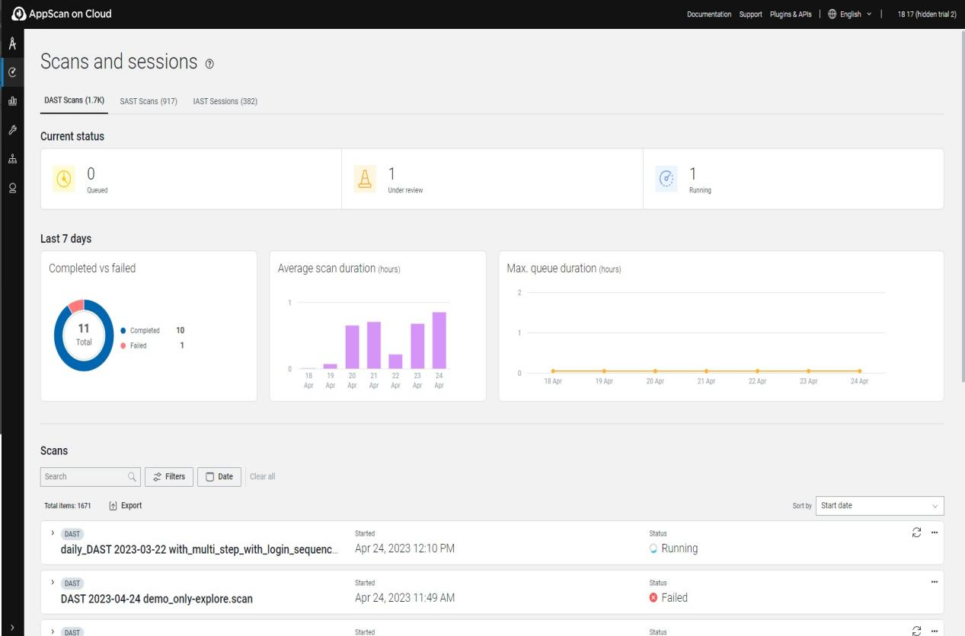

Conclusion
VAPT tools are essential for maintaining the security of web applications by identifying vulnerabilities and assessing potential threats. The tools discussed in this report offer a range of functionalities from automated vulnerability scanning to advanced penetration testing. Implementing these tools can help organizations protect their web applications from various security risks.

References
• OWASP Foundation. "OWASP Top Ten Web Application Security Risks". OWASP.
• Mozilla Developer Network (MDN). "HTTP Overview". MDN Web Docs.
• RFC 2616. "Hypertext Transfer Protocol -- HTTP/1.1". IETF.• MDN Web Docs. "Introduction to WebSockets". MDN Web Docs.

Tools
- OWASP ZAP Official Site. Available at: OWASP ZAP
- Nessus Official Site. Available at: Nessus
- Qualys Web Application Scanner. Available at: Qualys
- Burp Suite Official Site. Available at: Burp Suite
- Metasploit Official Site. Available at: Metasploit
- Nikto Official Site. Available at: Nikto
- Acunetix Official Site. Available at: Acunetix
- IBM AppScan Official Site. Available at: IBM AppScan

